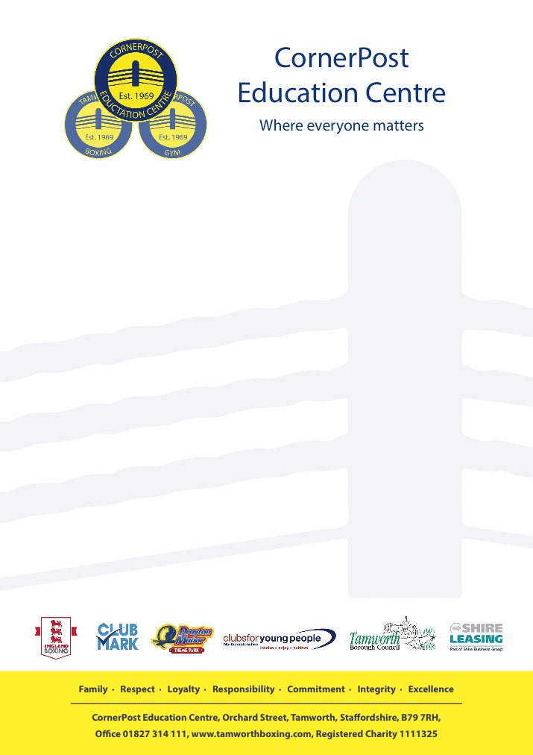

22nd January 2021

Dear Parents/Carers

CornerPost Education have invested in the opportunity for our pupils to enjoy woodwork sessions delivered by Training Initiative. These sessions will teach maths, measuring, hand eye coordination in a fun practical lesson. These sessions will take place at Training Initiative Victoria Road in Tamworth.

The sessions will run every Wednesday and Friday.

Each child will have an opportunity to attend a session, there will also be the opportunity to gain extra sessions based on good behaviour.

Children who are on transport to Burton, times will not change.

Yours Sincerely

CornerPost Education Centre